March 13, 2024

**Memorandum**

Subject: Proposal for Implementing Carbon Emission Monitoring System

We are writing to present a proposal for the implementation of a comprehensive Carbon Emission Monitoring System within our organization. This memorandum includes a one-page executive summary outlining the key components and benefits of the proposal.

**Executive Summary:**

**Objective:** The objective of this proposal is to address the challenge of accurately tracking and managing carbon emissions across our operations, ensuring regulatory compliance and enhancing our commitment to sustainability.

**Problem Statement:** Many organizations face difficulties in monitoring carbon emissions due to disparate data sources, lack of real-time monitoring capabilities, and absence of predictive analytics. This deficiency exposes organizations to regulatory, financial, and reputational risks, while also contributing to environmental challenges.

**Proposed Solution:** Our solution involves implementing a cloud-based Carbon Emission Monitoring System, leveraging advanced technology and industry best practices. The system will incorporate sensors installed in key emission points, integrated with cloud infrastructure for real-time data processing and analysis. Strategic partnerships with industry leaders like AWS will ensure a seamless implementation process.

**Expected Benefits:** By investing in this solution, we anticipate achieving regulatory compliance, reducing operational costs, enhancing brand reputation, and contributing to broader climate change mitigation efforts. Financially, the system offers potential cost savings through improved energy efficiency and reduced regulatory fines. Non-financially, it underscores our commitment to sustainability and responsible business practices.

**Funding Request:** We are seeking funding for sensor procurement, installation, and integration, as well as ongoing operational costs for cloud services and data processing. The total initial setup cost is estimated at $300,000, with monthly operational expenses ranging from $2,070 to $5,210, depending on usage.

**Conclusion:** Implementing a Carbon Emission Monitoring System is not only a prudent business decision but also an investment in our future. We respectfully request your support in funding this initiative and invite you to join us in shaping a more sustainable future for our organization and the communities we serve.

Thank you for considering our proposal.

Sincerely,

Sophie Panagrossi, Benjamin ​​Tisinger, Zane Alderfer, Yesul Song

**Co2 and Carbon Emissions Tracking in the Cloud**

Sophie Panagrossi, Benjamin ​​Tisinger, Zane Alderfer, Yesul Song

IST-615 Cloud Management

**The Carbon Tracking Chllenge**

**Problem Description:**

Many organizations find themselves at a significant disadvantage due to their inability to accurately track and manage carbon emissions across their operations. This deficiency obstructs their path toward making informed, data-driven decisions necessary for reducing their environmental footprint. The root causes of this inefficiency include disparate data sources, a lack of real-time monitoring capabilities, and an absence of predictive analytics to guide strategic emissions reduction initiatives. For example, a medium-sized manufacturing company might be incurring upwards of $100,000 annually in fines, lost business opportunities, and increased operational costs, all due to inefficient energy use and a failure to demonstrate commitment to sustainability efforts.

**Affected Parties:**

The Organization: Faces regulatory, financial, and reputational risks.

Stakeholders (Customers and Investors): Demand greater accountability and transparency regarding environmental sustainability.

The Wider Community and Environment: Suffers the impacts of unchecked carbon emissions, contributing to global climate change challenges.

**Who Will Benefit:**

The Organization: Will achieve regulatory compliance, enjoy operational cost savings, enhance its brand reputation, and enhance its capacity for informed decision-making regarding emission reductions.

Stakeholders: Will appreciate increased transparency and commitment to sustainability, aligning with their environmental values and expectations.

The Broader Community and Environment: Will benefit from the concerted efforts to reduce carbon emissions, thereby contributing to broader climate change mitigation efforts.

**Solution**

**Overview:**

With a general overall rise in greenhouse gas emission, it would be wise to address the problem and be able to pinpoint exactly what is causing the highest amount of input to the emissions. An overall trend by sector since 1990 can be seen below.

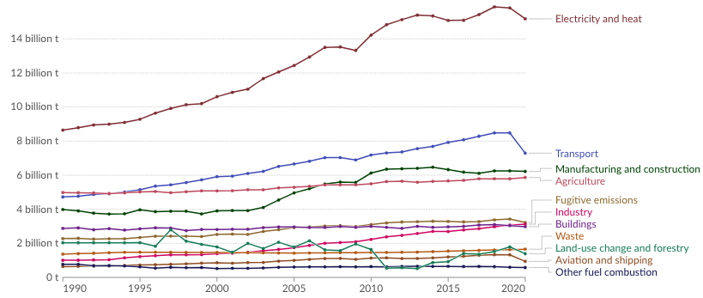

<https://ourworldindata.org/emissions-by-sector>

With manufacturing and construction being among one of the highest contributors to the emissions, it could be of interest to monitor their emissions and try to mitigate them if possible. With CO2 emissions on the rise, companies providing accountability and transparency in terms of their CO2 emissions will be a valuable asset for monitoring and potentially maintaining CO2 emissions. Providing software that can definitively track the emissions by company could be a good stepping stone in developing blueprints as to what companies could be doing better to mitigate their CO2 emissions. The goal of this software would be to pinpoint the key sources of these emissions within a company in order to develop new arrangements of how companies can more effectively be “green.” Along with identifying the areas of concern with initial monitoring, the goal would be to then maintain a certain level of emissions going forward. Continuous use of the sensors and monitoring in place will allow these companies to do so.

**Idea**:

The goal of the plan would be to leverage existing software or cloud applications that can suitably suffice as proper monitoring and tracking devices for these emissions. The sensors would be introduced to multiple areas such as factories, vehicles, plants, etc. The hardest part of this idea would be getting all these companies acclimated to our cloud design. As mentioned below in the proposed cloud design, the goal would be to leverage AWS cloud applications to develop our cloud design. The logistics of this design is discussed in depth below. However, the diagram below shows the different scopes of carbon emissions and this cloud application would ideally focus on the 3rd scope with transportation and distribution as well as fuel and energy consumption.

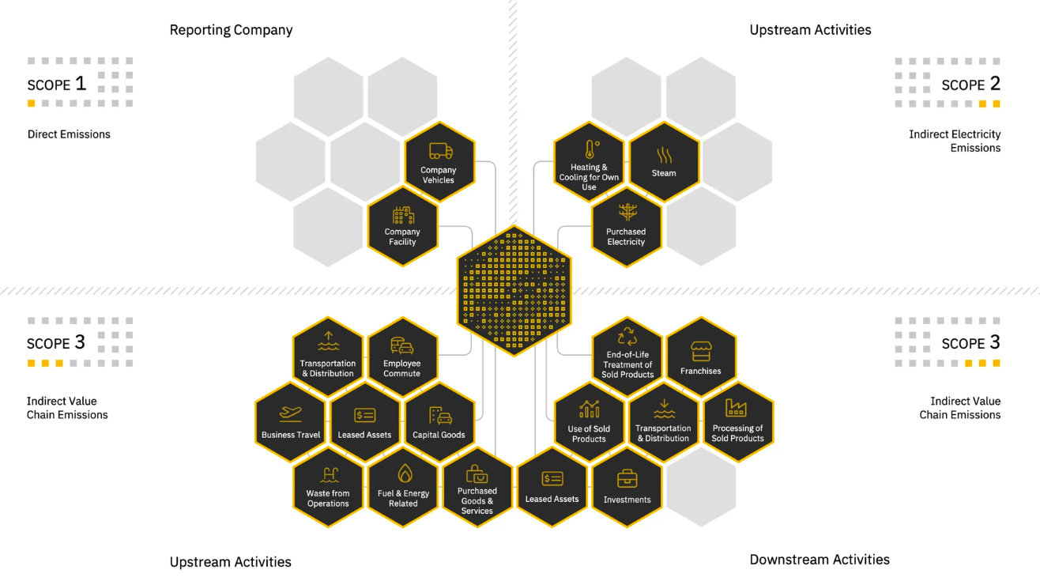

<https://www.persefoni.com/learn/best-carbon-accounting-software>

**End Goal**:

The ultimate goal of this cloud application would be to bring awareness to these companies with our software to ideally work toward a better future. A future that can be enjoyed by generations to come due to the precautionary and/or damage control effort put forth by cloud applications such as this. If companies are willing to comply with standards that can be established by these monitoring tools then the economy can continue to thrive as a result. The companies have to be willing to spend a little extra or potentially not cut corners in the name of a better environment if they’re serious about acclimating our application. The technology is readily available and begging to be used so it’s the duty of companies that run the economy to set the standard for a better world.

**Cloud Design**

**Data Collection:**

When discussing the collection of data in reference to Co2 and Carbon emissions the most likely thing that first pops into mind is how to collect the data. The first step in our design process for collecting data would be to oversee and install sensors into our factories, plants, buildings, workshops and vehicles to begin monitoring our emissions. This of course completely relies on the business sector and how or what is manufactured. Some of the big players in the emissions sensor markets are Senseair, sensirion and amphenol.

**Sensor Data and Cloud Processes:**

[**https://aws.amazon.com/iot-core/**](https://aws.amazon.com/iot-core/)

[**https://aws.amazon.com/kinesis/data-streams/**](https://aws.amazon.com/kinesis/data-streams/)

[**https://aws.amazon.com/s3/**](https://aws.amazon.com/s3/)

[**https://docs.aws.amazon.com/glue/**](https://docs.aws.amazon.com/glue/)

The cloud provider market as we know is full of companies that offer a wide range of products and services. The biggest player in this space is AWS - Amazon Web Services, for the remainder of this project we will use AWS and their products for our cloud design and implementation. We cemented the first step in our process to be green forward by installing sensors and other devices to monitor our pollution output. The next step into the process is to use AWS IoT Core Systems. IoT core software can be deployed in our cloud environment to connect to our sensors and pull in the data in message format.

Once we have the data from the sensor flowing into AWS IoT Core we can then layer our data real time into AWS Kinesis Data Stream. AWS Kinesis Data Streams is a serverless data service that makes it easy to capture, process, and store data streams at any scale. The next step in our process is making sure we have the data stored for cleaning, consumption, reporting and regulatory compliance. This will be handled by AWS S3. AWS S3 is an object storage service that offers industry-leading scalability, data availability, security, and performance. This will act as our data warehouse in the sense of reliability storing and maintaining data for our business providers.

The final few components that we need to consider as we have our data flowing is how we plan to cleanse, modify, report and publish our data. Next in our process we will connect AWS Glue to our S3 Buckets. AWS Glue is a scalable, serverless data integration service that makes it easy to discover, prepare, and combine data for analytics, machine learning, and application development. With glue handling how our data can be shaped we will also use the tool Glue Brew which can help clean and normalize our data for consumption. This cleaned data will be processed back into our S3 buckets for storage. Next, we will use snowflake as a data storage and transformation layer. Snowflake will allow us to have a secondary redundancy in terms of data storage and transformation. This will also act as a query engine to query, download and report on our data. Lastly, we will have the ability with snowflake and the ODBC drivers to connect outside reporting platforms such as Tableau, PowerBi, Microsoft Report builder and excel to grab the finished data and then push out visualization reports and excel data.

Overall I believe this structure would work efficiently and I have attached a sample diagram of what a flow chart might look like for this carbon emissions data. I am in no way a master of Snowflake or AWS. Some of thesecomponents may play nice with each other while some may be extremely difficult to use or apply to this specific situation.

**Finance Analysis**

**Initial Setup Costs: $300,000**

Costs include the purchase and installation of sensors from the providers mentioned above and then placing them at emission points such as factories, plants, buildings, workshops, and vehicles. The big driving factor here price wise is the cost of purchasing and then installing these sensors. While gathering data on the price of these sensors can be hard, we roughly estimate the pricing of individual sensors at $100 to $100,000. We can use a baseline of 500 sensors across our portfolio at $500 a piece this would bring the sensor cost to around $250,000. Then we factor in the AWS Connection for the IoT core bringing that setup cost to around $30,000 depending on development and if custom designs are needed.

**Ongoing Expenses: $5,210 Estimated Monthly**

These have to deal with the AWS service costs and Snowflake usage. AWS IoT Core pricing is based on the number of messages sent to the cloud, with the first 1 billion messages per month billed at $1 per million messages. Assuming the high amount of data collection, these costs could be placed around $1,000 to $2,000 per month. AWS Kinesis Data Streams is priced on the hour and payload input unit, which could run us around $300 to $600 per month based on data volume and throughput. S3 storage costs would depend on the amount of data we stored; for a mid size organization you would expect the storage costs to be around $200 - $500 a month. AWS Glue's pricing involves a combination of data processing units for individual jobs that we run and could also include monthly triggers. A moderate usage might cost the firm between $200 to $400 monthly. Snowflake costs will vary significantly based on storage, computing, and data transfer needs, but for a scenario like this, a reasonable estimate might be $500 to $2,000 monthly, depending on the Snowflake edition and usage pattern. Additional costs for visualization tools like Tableau or PowerBI subscriptions should also be considered, which could add another $70 to $210 per user per month.

**Pricing Conclusion:**

Our initial phase of implementing a cloud-based system for tracking CO2 and carbon emissions could range from roughly $270,000 to $300,000 considering sensor purchasing and system setup. Ongoing operational costs driven by cloud service usage and data processing needs, could range from approximately $2,070 to $5,210 per month.

**Setup - $300,000 (High End)**

**Monthly Cost - $5,210 (High End)**

**Fund Request**

We are seeking funding to implement a comprehensive solution for carbon emission monitoring within our organization. Our proposal presents a strategic opportunity to address a critical environmental challenge while simultaneously enhancing operational efficiency and reputation. Here's why we believe this investment is essential:

**Why It's a Good Idea:**

Implementing a robust carbon emission monitoring system aligns with our commitment to sustainability and responsible business practices. By accurately tracking and managing our carbon footprint, we not only meet regulatory requirements but also demonstrate our dedication to environmental stewardship. Moreover, investing in cutting-edge technology underscores our commitment to innovation and leadership in our industry.

**What is Required:**

To implement our proposal, we require funding for sensor procurement, installation, and integration with cloud-based infrastructure. Additionally, ongoing operational costs for cloud services and data processing need to be accounted for. The total initial setup cost is estimated at $300,000, with monthly operational expenses ranging from $2,070 to $5,210, depending on usage.

**Expected Benefits:**

Financially, implementing a carbon emission monitoring system offers the potential for significant cost savings through improved energy efficiency and reduced regulatory fines. Moreover, enhancing our brand reputation as a sustainable and environmentally-conscious organization can lead to increased customer loyalty and investor confidence. Non-financially, our efforts contribute to broader climate change mitigation efforts, ensuring a more sustainable future for our organization and the communities we serve.

**Conclusion:**

In conclusion, investing in a carbon emission monitoring system is a strategic imperative for our organization. By allocating resources towards this initiative, we demonstrate our commitment to sustainability and responsible corporate citizenship. We believe that implementing this solution will yield tangible benefits, both financially and reputationally, while also contributing to broader environmental goals. We respectfully request your support in funding this essential project, and we are confident that together, we can achieve our shared objectives. Thank you for considering our proposal.